SIMATS ENGINEERING (SAVEETHA SCHOOL OF ENGINEERING)
Department of Computer Science and Engineering
ASSESSMENT TOOL 1 – CLASS TEST (5 Questions)

Annexure A – Class Test
1. A survey estimates the average monthly income (₹) of two cities:

Represent this dataset using a suitable graph to visualize uncertainty. Justify your choice and interpret which city has more reliable estimates.
Solution Explanation & Implementation:
• Selected Graph & Visual Design: Bar Chart with 95% Confidence Interval (CI) Error Bars (or Point Interval Plot).
• Methodological Justification: Point estimates (means) alone fail to communicate underlying sample variance, sample size, or sampling error. Displaying 95% confidence intervals visually encodes the range within which the true population mean income is expected to lie with 95% statistical confidence, enabling simultaneous evaluation of magnitude and precision.
• Quantitative Metrics & Calculations: City A: Mean Income = ₹25,000, 95% CI = ±₹2,000 (CI Range: ₹23,000 – ₹27,000; Relative Margin of Error = ±8.00%). City B: Mean Income = ₹27,000, 95% CI = ±₹5,000 (CI Range: ₹22,000 – ₹32,000; Relative Margin of Error = ±18.52%). Standard error for City A (SE ≈ 1,020.41) is less than half that of City B (SE ≈ 2,551.02).
• Reliability Interpretation: City A's estimate is significantly more reliable. City A has a much narrower confidence interval (±₹2,000 vs. ±₹5,000), indicating lower sample variance, smaller standard error, and higher measurement precision. Although City B boasts a higher point estimate (₹27,000), its wide uncertainty interval (spanning ₹22,000 to ₹32,000) overlaps heavily with City A's range, meaning we cannot conclude with statistical significance that City B's average income is higher than City A's.
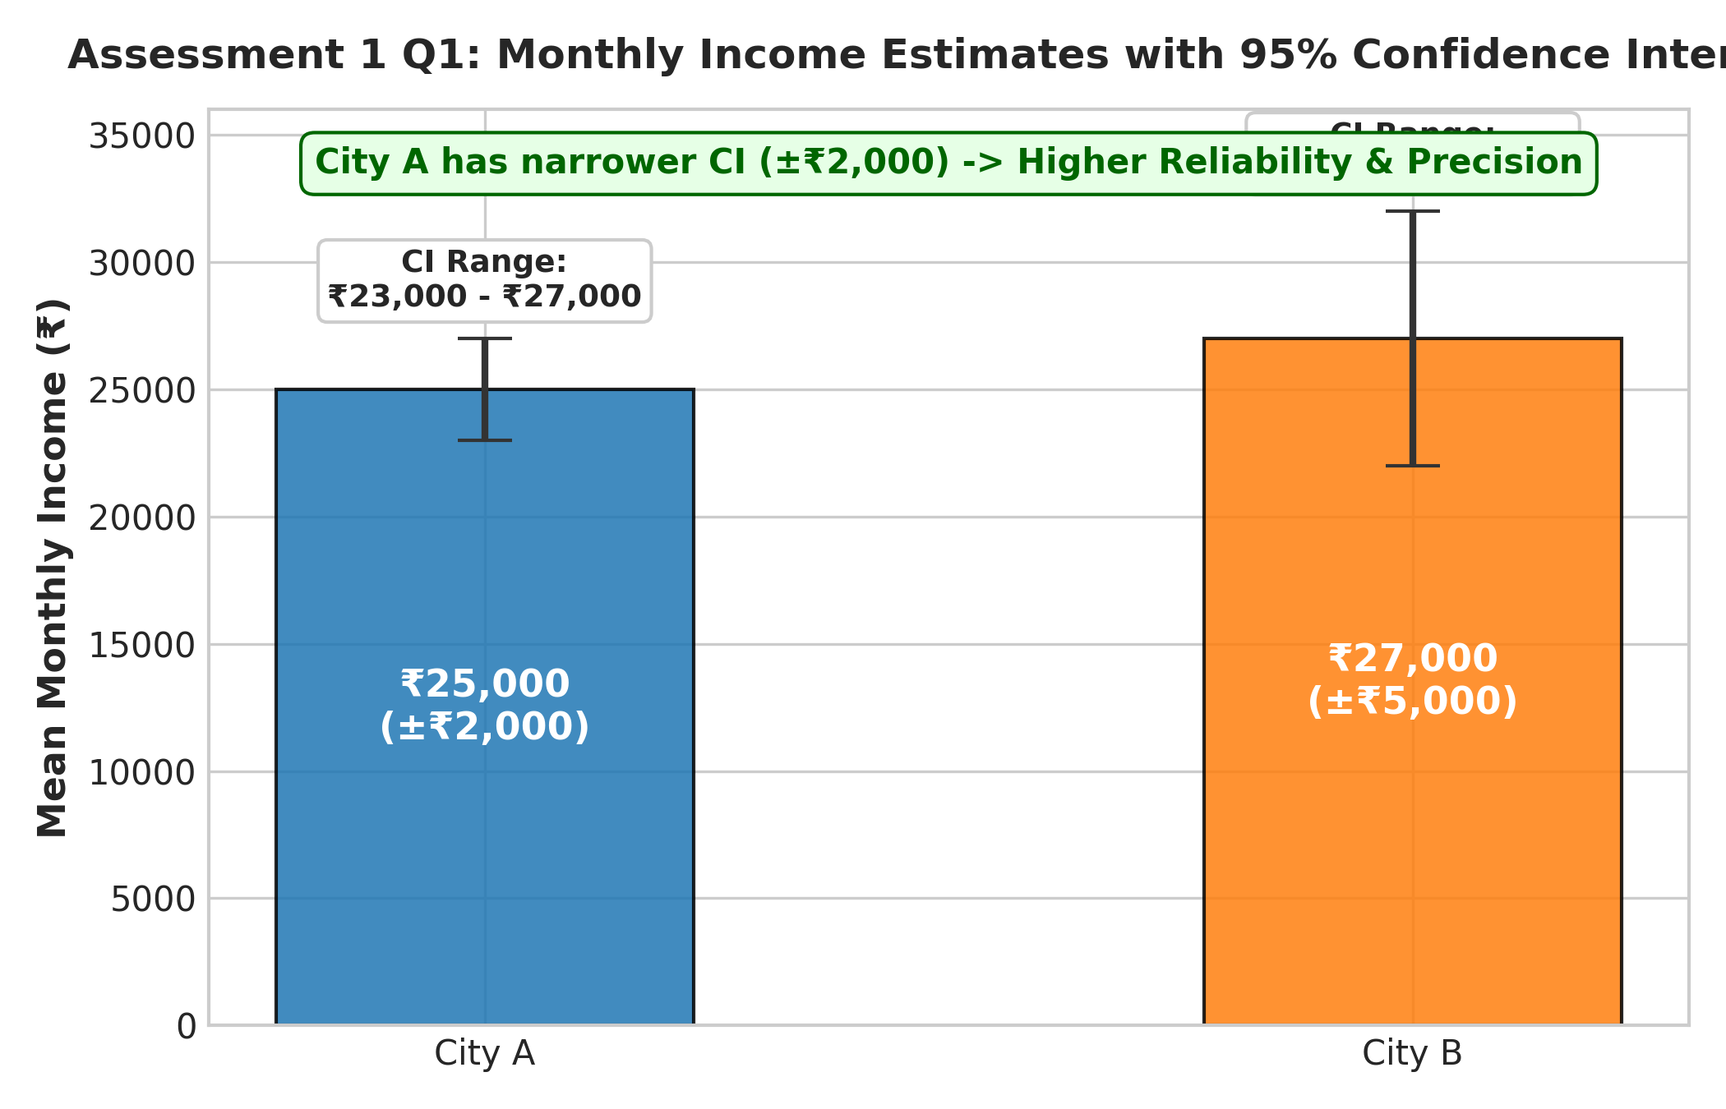
Figure 1.1: Average Monthly Income Comparison between City A and City B with 95% Confidence Intervals.
2. A dataset contains exam scores of 200 students, where many students have similar scores:

Choose an appropriate visualization to avoid overplotting. Explain how techniques like jittering or transparency can improve clarity.
Solution Explanation & Implementation:
• Overplotting Problem Analysis: Overplotting occurs when multiple data points share exact discrete coordinates, causing markers to obscure one another. In this dataset of 200 student exam scores (where scores are discrete values: 50, 60, 70, 80, 90), plotting 200 points directly results in only 5 visible dots, completely hiding the frequency distribution and true sample count (n=200).
• Jittering Technique: Adding small, controlled pseudo-random noise (e.g. uniform horizontal displacement Δx ~ U(-1.5, +1.5)) spreads points across discrete score bands, rendering individual data instances visually separable without altering true discrete values.
• Alpha Transparency: Setting point opacity α < 1.0 (e.g., α = 0.35) allows overlapping points to stack additively. High-density scores (e.g., score 70 with n=60) produce dark, saturated clusters, while low-density scores (e.g., score 90 with n=25) remain faint.
• Alternative Visualization Structures: A Frequency Bar Chart or Dot/Beeswarm Plot explicitly represents category counts and modal peaks without point overlap.
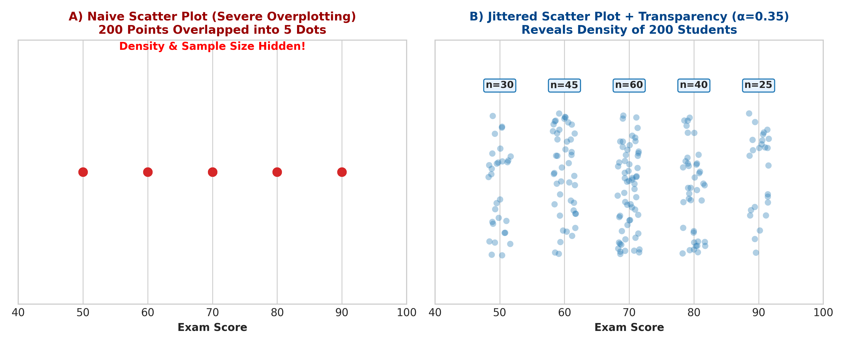
Figure 1.2: Comparison between Naive Scatter Plot (Severe Overplotting) and Jittered Scatter Plot with Alpha Transparency.
3. A company reports revenue growth:

Create a graph that avoids misleading axes and follows the proportional ink principle. Explain how improper axis scaling could distort interpretation.
Solution Explanation & Implementation:
• Proportional Ink Principle: The visual area or length of a shaded visual element (such as a bar) must be directly proportional to the numerical data value it represents (Edward Tufte / Claus Wilke).
• Axis Scaling Distortion Analysis: Truncating the vertical y-axis (e.g., starting at 95 instead of 0) reduces the visual baseline. The bar for 2021 (100 lakhs, height 5 units) appears one-fourth the height of 2023 (115 lakhs, height 20 units), visually exaggerating a modest 15% revenue growth into an artificial 400% visual increase.
• Recommended Proper Axis Design: Always enforce a zero baseline (y=0) for bar charts to preserve visual ratios. For line plots where non-zero baselines are used to examine small fluctuations, explicitly indicate axis breaks and add percentage change callouts.
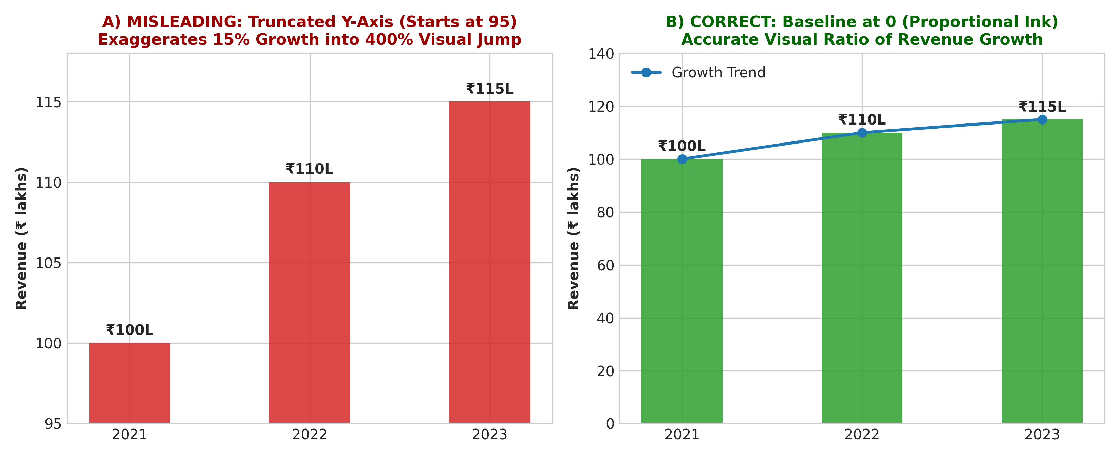
Figure 1.3: Revenue Growth Visualization: Misleading Truncated Axis vs. Correct Baseline Proportional Ink Chart.
4. A dataset shows profit/loss across departments:

Design a suitable visualization ensuring accessibility. Suggest color choices and explain how to avoid misuse of color for colorblind users.
Solution Explanation & Implementation:
• Accessibility & Colorblindness Pitfall: Traditional Red/Green color palettes are indistinguishable to people with Red-Green Color Vision Deficiency (Deuteranopia/Protanopia, affecting ~8% of males). Profit (Green) and Loss (Red) appear as identical brownish-yellow tones.
• Accessible Color Choices: Utilize high-contrast colorblind-safe palettes such as Okabe-Ito Blue (#0072B2) for Profit and Vermilion/Orange (#D55E00) for Loss.
• Redundant Dual Encoding: Combine color encoding with secondary non-color visual channels: directional symbols (Up Arrow ▲ for Profit, Down Arrow ▼ for Loss), direct text labels, and positive/negative horizontal bar orientation around a zero baseline.
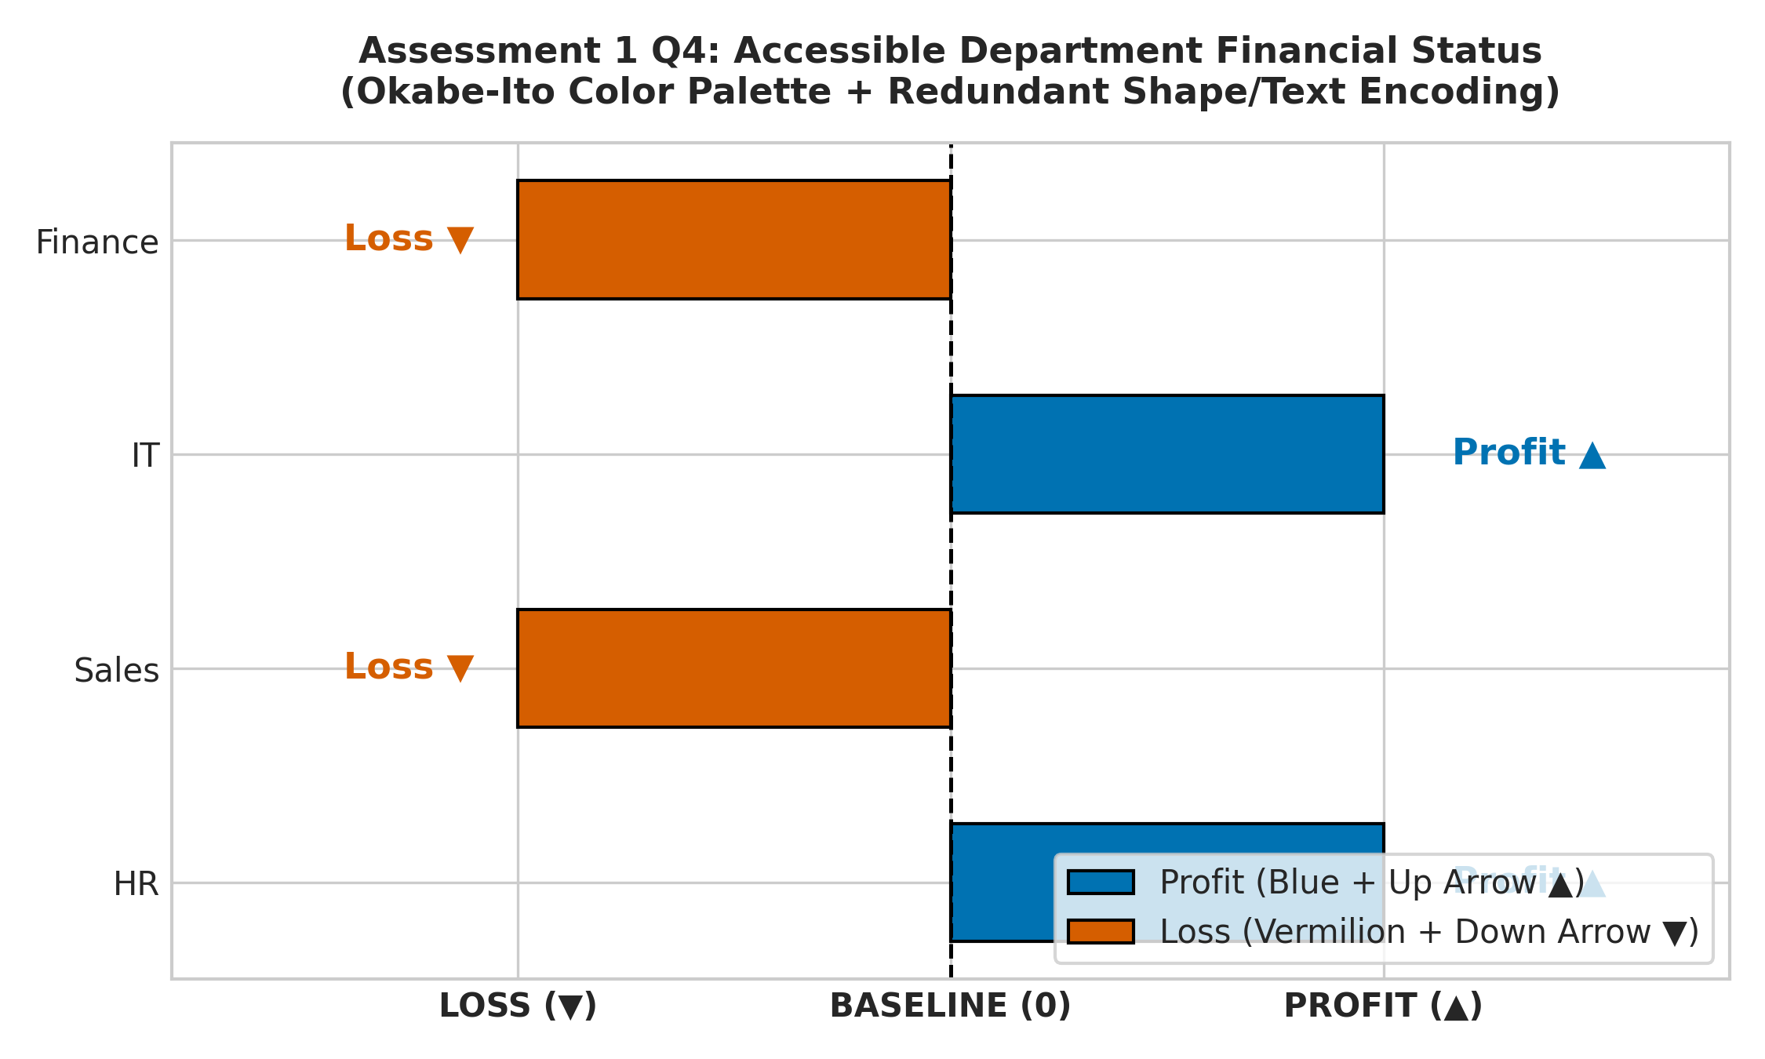
Figure 1.4: Accessible Diverging Department Financial Status Chart using Okabe-Ito Palette and Shape/Text Indicators.
5. A factory produces light bulbs with a 5% defect rate. A quality control engineer wants to visualize the probability of defects in batches of 20 bulbs.
Represent the probability distribution using a suitable graph (e.g., hypothetical outcome plot or probability plot). Interpret the likelihood of observing 0, 1, or more defective bulbs.
Solution Explanation & Implementation:
• Statistical Model & Formula: Quality control inspection modeled by Binomial Distribution X ~ Binomial(n=20, p=0.05). Formula: P(X=k) = C(20,k) * (0.05)^k * (0.95)^(20-k).
• Calculated Probabilities: P(X=0 defects) = (0.95)^20 = 35.85%; P(X=1 defect) = 20 * 0.05 * (0.95)^19 = 37.74%; P(X=2 defects) = C(20,2) * (0.05)^2 * (0.95)^18 = 18.87%; P(X >= 1 defects) = 1 - P(0) = 64.15%; P(X >= 2 defects) = 1 - (P(0)+P(1)) = 26.41%.
• Interpretation & HOP Utility: There is a 35.85% probability of a defect-free batch and a 37.74% chance of observing exactly 1 defect. Observing 1 or more defects occurs in 64.15% of batches. Hypothetical Outcome Plots (HOPs) visually sample simulated quality control batches over time, enabling intuitive perception of defect frequency without relying on static probability density functions.
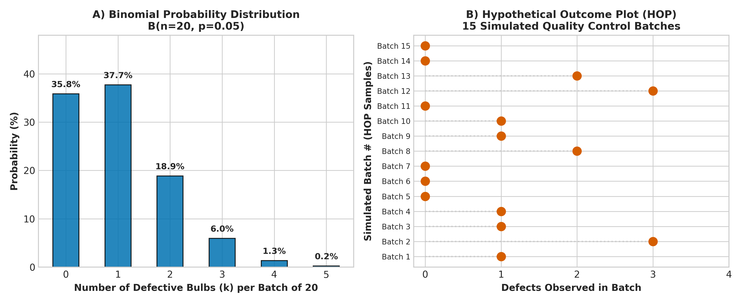
Figure 1.5: Binomial Probability Mass Function (PMF) and Simulated Hypothetical Outcome Plot (HOP) for Light Bulb Batches.
Rubrics for Calculation

Course Code: | DSA06 | Course Title: | Data Handling and Visualization
CO Assessed: | CO5 – Precision (BL6) | Assessment: | Assessment Tool 1 – Class Test
Weightage: | 40% of CIA | Total Marks: | 50 (5 Questions × 10 Marks)
CO5 Statement: | Create effective and interactive visualizations by integrating data wrangling and advanced visualization tools (BL6)
Student Name: | Gadwal Mohammad Muzammil | Reg. No.: | 192424279
Section / Batch: | AI & DS | Date: | 13-08-2026
Code of Conduct
I _Gadwal Mohammad Muzammil-192424279__ (Name / Reg No) certify that this submission is my original work and that I have adhered to the guidelines specified for this assessment. I understand that any violation of academic integrity rules will result in disciplinary action.

Signature of the Student: ___Muzammil…__
Instructions
- This test contains 5 questions, each carrying 10 marks. Total: 50 Marks.
- No negative marking. Unanswered questions carry zero marks.
- No calculators or electronic devices permitted.
- Duration: 60 minutes.
Section / Topic | Focus | Q Nos | Marks
Uncertainty & Confidence Intervals | Uncertainty of point estimates, confidence intervals, trend estimation | 1 | 10
Handling Overplotting | Overlapping points, jittering, transparency | 2 | 10
Principles of Effective Visualization | Proportional ink principle, avoiding misleading axes | 3 | 10
Accessibility & Misuse of Color | Color accessibility, avoiding misuse of color | 4 | 10
Probability & Hypothetical Outcome Plots | Probability distribution and hypothetical outcome plots | 5 | 10
GRAND TOTAL: |  | 50 Marks
City | Mean Income | Confidence Interval
A | 25,000 | ± 2,000
B | 27,000 | ± 5,000
Score | Frequency
50 | 30
60 | 45
70 | 60
80 | 40
90 | 25
Year | Revenue (₹ lakhs)
2021 | 100
2022 | 110
2023 | 115
Department | Status
HR | Profit
Sales | Loss
IT | Profit
Finance | Loss
Criteria | Weightage | Level 4 – Exemplary | Level 3 – Proficient | Level 2 – Developing | Level 1 – Beginning | Marks
Understanding of Concepts | 25% | Demonstrates thorough, accurate understanding of concepts | Good understanding with minor gaps | Basic understanding with some misconceptions | Poor understanding; major misconceptions
Explanation | 25% | Detailed, well-explained answers with relevant examples | Clear explanation with adequate details | Limited explanation; lacks depth | Poor or unclear explanation
Application | 20% | Effectively applies concepts with strong analytical ability | Applies concepts with minor errors | Limited application with weak analysis | No application or incorrect analysis
Organization | 15% | Well-structured answers with logical flow and coherence | Organized with minor issues in flow | Basic structure, lacks clarity | Poor organization, incoherent answers
Accuracy | 10% | Completely accurate and covers all required points | Mostly accurate with minor omissions | Partially correct with missing points | Incorrect answers with major gaps
Faculty In-charge | Course Coordinator | Head of Department
Signature: _______________ | Signature: _______________ | Signature: _______________
Date: ___________________ | Date: ___________________ | Date: ___________________

